Grid patches and grid patch software for the GEBCO One Minute Grid

Introduction

Version 1.0 of the GEBCO One Minute Grid is included on the Centenary Edition of the GEBCO Digital Atlas CDROM set. To fix bugs in this global grid file we intend to make available a series of grid patches. These are sections of grid file, in netCDF, which fix a bug for a particular geographic area. The patches are applied to the global GEBCO One Minute Grid file, also in netCDF, using software designed to run in a Microsoft Windows environment.

During the patching process the version number of the grid file is updated. The software will also overwrite your copy of the grid file with the grid patch. No backups are automatically made during the patching process. If required, the user must make any necessary backups themselves.

It is intended that a series of grid patches will be made available. In order to keep the version number of your copy of the global GEBCO One Minute grid file up-to-date you must apply all the available grid patches and the grid patches must be applied in order.

How to apply the grid patches

To use the grid patch software, gebco_gridfix.exe, you will need a PC running under Microsoft Windows 95 or later.

You will need to:

- Copy the global GEBCO One Minute Grid file from the Centenary Edition of the GEBCO Digital Atlas CDROM set into a directory on the hard disc of your PC. This global grid file is called gridone.grd and is located in the directory Grid on disc 1 of the CDROM set.

- Copy the netCDF link library file, netcdf.dll, from the top level directory of disc 1 of the CDROM set into a directory on the hard disc of your PC where you will run the grid patch software from.

- Download the grid patch files and grid patch software from the web onto the hard disc of your PC. These files can be found on the ‘Hints, bugs and fixes’ page for the GEBCO Digital Atlas (http://www.bodc.ac.uk/help_and_hints/errata/gebco.html).

To use the software, simply run the file gebco_gridfix.exe. You will then be presented with a dialogue box.
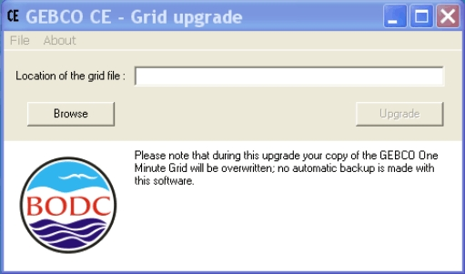

In the Location of the grid file section enter the name and path of the global GEBCO One Minute Grid file to be updated. You can use the Browse button to locate the file on your computer system.

Use the Upgrade button to locate the grid patch to be applied to the global grid file. The grid patches must be applied in order and all patches must be applied. The order number is given by the file extension, so gebco_gridpatch1.001 should be applied before gebco_gridpatch2.002.

During the patching process a progress message is displayed in the dialogue box window. This provides information on the version number of the patched grid file.

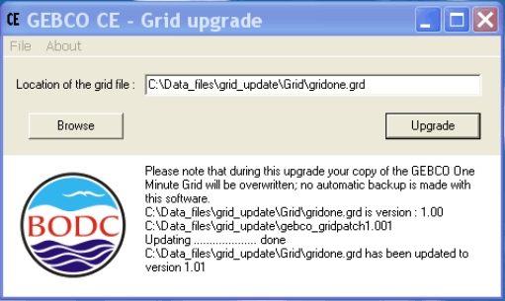

From the File menu use the Exit button to exit from this programme. Use the About button to find out about copyright and the version number of the software.
Grid version numbers

Once you have applied a grid patch to the global GEBCO One Minute Grid file, the version number of this file is updated. The grid patches must be applied in order and all patches must be applied to keep the grid version number up-to-date. The version number information is stored in the header section of the global grid file.

Using the patched grid file with the GEBCO Digital Atlas Software Interface

If you now want to use the patched GEBCO One Minute grid file with the GEBCO Digital Atlas (GDA) software interface then you must run the software from the hard disc of your PC rather than directly from the GDA CDROM.

Simply copy the contents of disc 1 onto the hard disc of your PC. You must replace the global GEBCO One Minute Grid file, gridone.grd, copied from the CDROM with the patched version of the grid that you have just created. The GEBCO One Minute Grid file is located in the sub directory Grid. So that the software interface will use the grid file, the patched version of the global grid file should also be called gridone.grd.

